# ANDROID APPLICATION THAT CREATES AN ALERT UPON RECEIVING A MESSAGE

##### Aim:

To develop a Android Application that creates an alert upon receiving a message.

##### Procedure:

**Creating a New project:**

* + Open Android Studio and then click on **File -> New -> New project.**

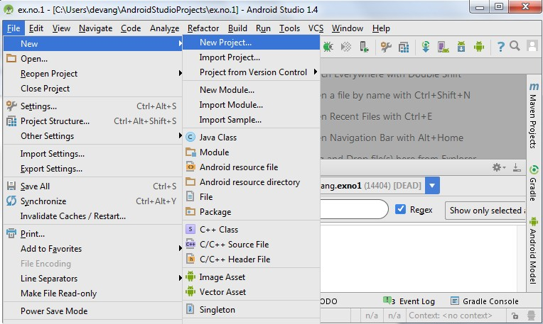

* + Then type the Application name as “**ex.no.10″** and click **Next.**

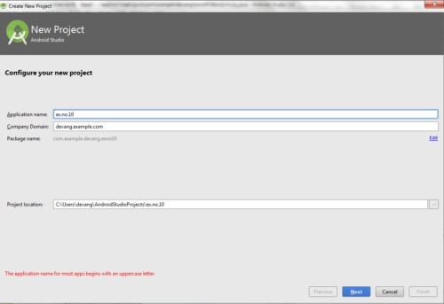

* + Then select the **Minimum SDK** as shown below and click **Next**.

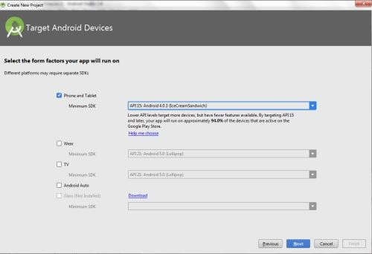

* + Then select the **Empty Activity** and click **Next.**

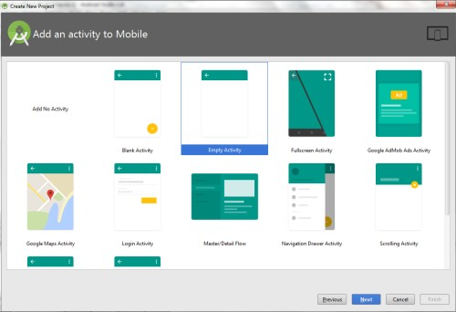

* + Finally click F**inish**.

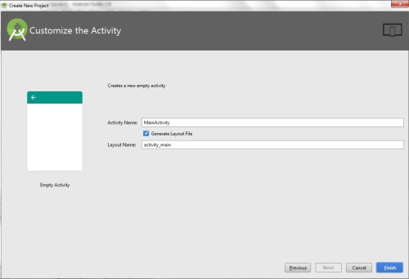

* + It will take some time to build and load the project.
  + After completion it will look as given below.

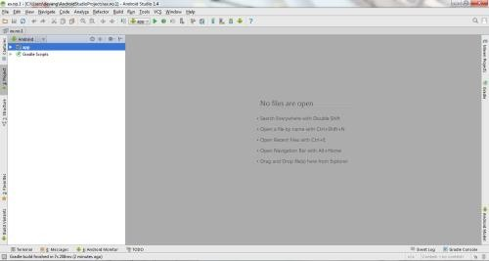

**Creating Second Activity for the Android Application:**

* + Click on **File -> New -> Activity -> Empty Activity.**

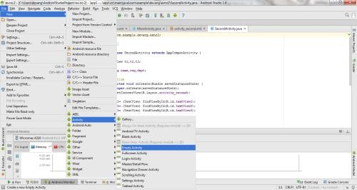

* + Type the Activity Name as **SecondActivity** and click **Finish** button.

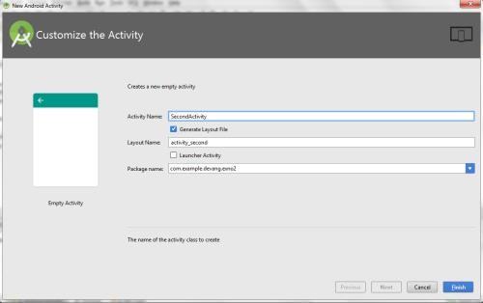

* + Thus Second Activity For the application is created.

**Designing layout for the Android Application:**

* + Click on **app -> res -> layout -> activity_main.xml.**

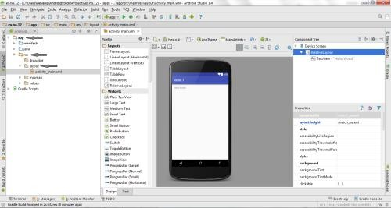

* + Now click on **Text** as shown below.

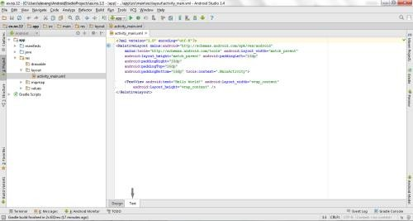

* + Then delete the code which is there and type the code as given below.

##### Code for Activity_main.xml:

<?xml version="1.0" encoding="utf-8"?>

<LinearLayout [xmlns:android="http://schemas.android.com/apk/res/android"](http://schemas.android.com/apk/res/android) android:layout_width="match_parent" android:layout_height="match_parent"

android:layout_margin="10dp" android:orientation="vertical">

<TextView

android:layout_width="wrap_content" android:layout_height="wrap_content" android:text="Message" android:textSize="30sp" />

<EditText

android:id="@+id/editText" android:layout_width="match_parent" android:layout_height="wrap_content" android:singleLine="true" android:textSize="30sp" />

<Button

android:id="@+id/button" android:layout_width="wrap_content" android:layout_height="wrap_content" android:layout_margin="30dp" android:layout_gravity="center" android:text="Notify" android:textSize="30sp"/>

</LinearLayout>

* + Now click on **Design** and your application will look as given below.

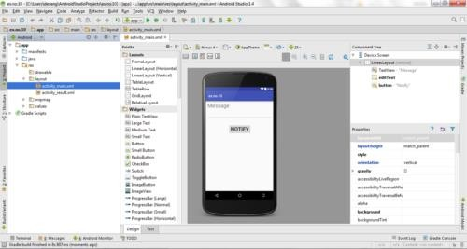

* + So now the designing part is completed.

**Java Coding for the Android Application:**

* + Click on **app -> java -> com.example.exno10 -> MainActivity.**

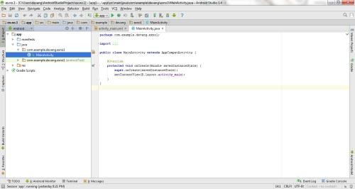

* + Then delete the code which is there and type the code as given below.

##### Code for MainActivity.java:

package com.example.exno10; import android.app.Notification;

import android.app.NotificationManager; import android.app.PendingIntent; import android.content.Intent;

import android.os.Bundle;

import android.support.v7.app.AppCompatActivity; import android.view.View;

import android.widget.Button;

import android.widget.EditText;

public class MainActivity extends AppCompatActivity

{

Button notify; EditText e; @Override

protected void onCreate(Bundle savedInstanceState)

{

super.onCreate(savedInstanceState); setContentView(R.layout.activity_main);

notify= (Button) findViewById(R.id.button); e= (EditText) findViewById(R.id.editText);

notify.setOnClickListener(new View.OnClickListener()

{

@Override

public void onClick(View v)

{

Intent intent = new Intent(MainActivity.this, SecondActivity.class);

PendingIntent pending = PendingIntent.getActivity(MainActivity.this, 0, intent, 0);

Notification noti = new Notification.Builder(MainActivity.this).setContentTitle("New Message").setContentText(e.getText().toString()).setSmallIcon(R.mipmap.ic_laun cher).setContentIntent(pending).build();

NotificationManager manager = (NotificationManager) getSystemService(NOTIFICATION_SERVICE);

noti.flags |= Notification.FLAG_AUTO_CANCEL; manager.notify(0, noti);

}

});

}

}

* + So now the Coding part is also completed.
  + Now run the application to see the output.

##### Output:

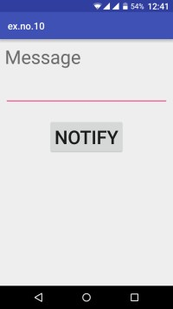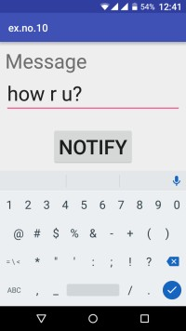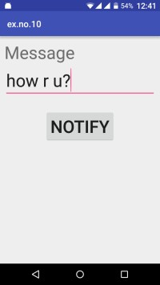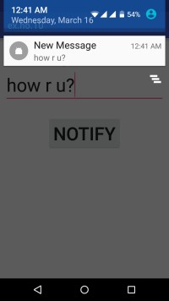

##### Result:

Thus Android Application that creates an alert upon receiving a message is developed and executed successfully.

### TASK 1:

Develop an android application to send an SMS to multiple recipients. [05]

### TASK 2

Develop an android application to send an email to multiple recipients. [05]

### TASK 3:

Develop an android application to generate a phone call. [05]

##### RESOURCES:

<https://www.codingconnect.net/mobile-application-development-lab/> <https://www.javatpoint.com/android-tutorial> <https://www.tutorialspoint.com/android> <https://developer.android.com/guide> [Https://developer.Android.com/training/basics/firstapp/creating-project](https://developer.android.com/training/basics/firstapp/creating-project)

[Https://www.raywenderlich.com/120177/beginning-Android-development-tutorial-](https://www.raywenderlich.com/120177/beginning-Android-development-tutorial-installingAndroid-studio) [installingAndroid-studio](https://www.raywenderlich.com/120177/beginning-Android-development-tutorial-installingAndroid-studio) <https://www.youtube.com/playlist?list=PLS1QulWo1RIbb1cYyzZpLFCKvdYV_yJ-E> [Https://www.udemy.com/java-tutorial/](https://www.udemy.com/java-tutorial/)

[Https://www.w3schools.com/xml/](https://www.w3schools.com/xml/) [Http://www.Androidguys.com/](http://www.androidguys.com/)